New Affordable Homes for Sale in Duboce Triangle

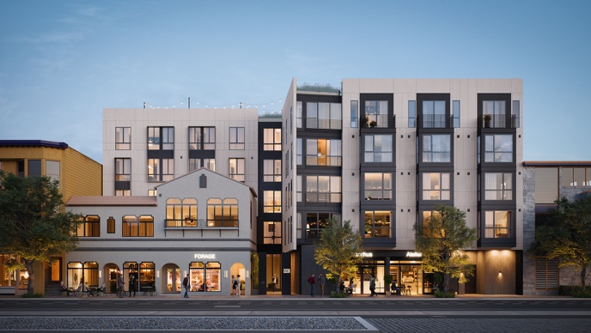 | 
2238 Market, 2238 Market Street, San Francisco

- 5 “Below Market Rate” homes for sale: 2 studios, 1 one-bedroom and 2 two-bedroom homes priced from $292,897 – $402,447 without parking and $324,964 – $448,880 with parking.
- 3 Parking spaces will be made available to BMR buyers by lottery rank.
- Applicants must be a first-time homebuyer and earn no more than the income levels listed below:

Household Size | One Person | Two Person | Three Person | Four Person | Five Person
Maximum Annual Income | $93,250 | $106,550 | $119,900 | $133,200 | $143,850

Applications must be received by 5PM on June 10, 2022. Apply online through DAHLIA, the SF Housing Portal at http://housing.sfgov.org. Due to COVID-19, applicants will apply online as we are not accepting paper applications.

For more information and assistance with your application, contact HomeownershipSF: (415) 202-5464 or info@homeownershipsf.org. For questions about the building and units, contact 2238 Market: (415) 683-3222 or info@2238market.com.

Units are monitored through the San Francisco Mayor’s Office of Housing and Community Development and are subject to owner occupancy and other restrictions. Visit www.sfmohcd.org for program information.

Open House Dates
May 19, 2022: 5-7PM
May 21, 2022: 9-11AM
May 31, 2022: 11AM-1PM

Lottery Date
July 5, 3:00PM
View lottery results at http://housing.sfgov.org

Continued on Next Page

2238 Market, 2238 Market Street, San Francisco, continued

All adult household members who will be on the title of the BMR unit must complete first-time homebuyer education through one of the City’s 5 approved housing counselling agencies in order to apply. Applicants can visit https://homeownershipsf.org/homebuyers for upcoming program orientations and workshops. Please sign up right away, as classes tend to fill up quickly.

Applicants for 2238 Market Street must obtain a loan pre-approval from one of the approved participating lenders listed at http://sfmohcd.org/mohcd-authorized-lender-list to apply.

All applicants are encouraged to apply. Lottery preference will be given to: *Certificate of Preference, **Displaced Tenant Housing Preference holders, ***Neighborhood Residents and households that currently live or work in San Francisco.

*Certificate of Preference (COP) holders are primarily households displaced in Redevelopment Project Areas during the 1960’s and 1970's.
** Displaced Tenant Housing Preference (DTHP) holders are tenants who were displaced by an Ellis Act eviction, Owner Move In eviction and tenants displaced by fire.
***Neighborhood Resident Housing Preference (NRHP) are residents living in the same supervisorial district or within ½ mile buffer of the project.

Please contact 415-701-5613 or visit www.sfmohcd.org for more information about lottery preferences.

BMR Unit | Bedroom Count | Bath Count | Square Feet | Floor | Price  w/o Parking | Income Maximum | Monthly HOA Dues w/o Parking
203 | 2 | 2 | 1,052 | 2 | $402,447 | 100% of AMI | $759.57
206 | 1 | 1 | 722 | 2 | $352,766 | 100% of AMI | $686.36
304 | 0 | 1 | 612 | 3 | $293,814 | 100% of AMI | $662.45
312 | 0 | 1 | 626 | 3 | $292,897 | 100% of AMI | $667.19
403 | 2 | 2 | 1,052 | 4 | $402,447 | 100% of AMI | $759.57
How to apply:

